**(A)**

1. This slider will keep moving to the left slowly.
2. This slider doesn’t disappear when users scroll down the page.
3. This slider will display pictures of different items.
4. The user will pay to have their items advertised here.

* R??? Per week.

**(B)**



1. This part has the company logo, which when you click it takes you back to the home page.
2. There is also a search bar to help the user to navigate the website easily and quickly.
3. There will also be a shopping cart, which users can fill with items before they cash out.

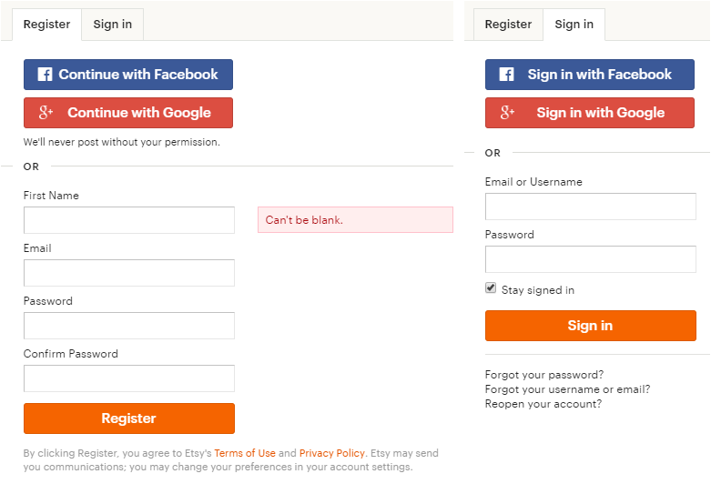

1. There is also a **sign in/register** option in which.

**To sign in**:

* The user will provide the following to sign in:

**Email**.

P**assword**.

* Or alternatively they can sign in with **Facebook** or with **Google+**.
* There’ll be a “**Stay signed in**” box to tick if the user doesn’t want to keep putting their details when returning to the website.
* If they have forgotten their password, there’ll be a “**forgot**” option, to recover their login details.
* The user will be required to enter their email address in order to receive a link for **resetting** their passwords.

**To register**:

* The user will provide the following to register:

**First name**.

**Email**.

**Password**.

**Confirm Password**.

* Or alternatively they can register with **Facebook** or with **Google+**.

1. There will be a “**sell on speedingcart**” option:

Which user will click and get directed to the seller’s page, where different selling methods will be explained, and the user will choose the ones they prefer.

**(C)**



1. This slider will keep moving to the left slowly.
2. This slider will display different ads in picture or video formats.
3. The user will pay to have their items advertised here.

* R??? Per week.

**(D)**

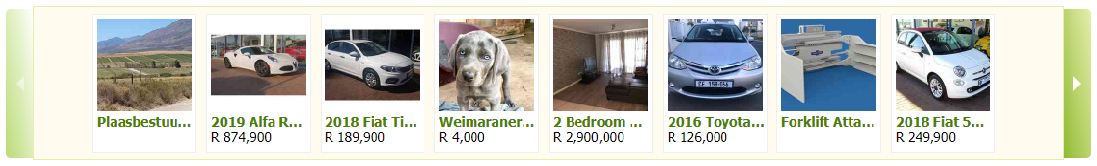

1. This slider will be moved sideways by clicking the arrows.
2. This slider will display pictures of different items.
3. The user will pay to have their items advertised here.

* R??? Per week.

**(E)**



1. This Ad space will display ads in picture or video formats.
2. This Ad space will not move when user scrolls down the page.
3. This Ad space will also appear in other pages of the website.
4. The user will pay to have their items advertised here.

* R??? Per week.

**(F)**

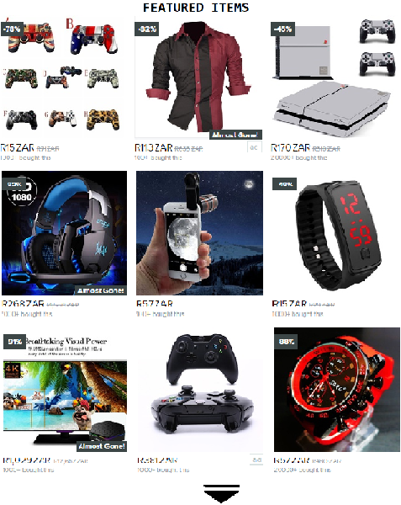

1. Users will pay to have their ads/items displayed here “front page”.
2. Users would scroll down the page for more items.
3. The user will pay to have their items advertised here.

* R??? Per week

**Auction System**

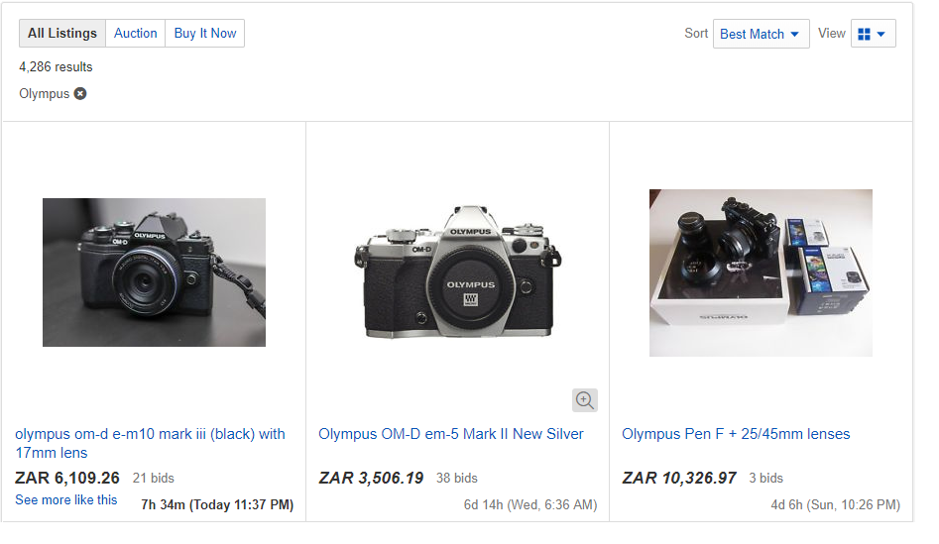

**How it will work**:

* The seller can choose between **0** and **30** days to make an **Auction**.
* The seller can choose to close and take the **highest bidder** anytime when the Auction is live.
* After which the Buyer will be notified and requested to **confirm** the purchase.
* Should they choose not to then they will be **panelised** a percentage of their chips.
* The seller will be **charged a fee** for cancelling an Auction, after buyers have placed bids.
* The seller will be able to set a **starting price** for their **Auction**.
* The seller is also able to choose the **Buy it now** option and the **Auction** option at once.
* Buyers will be requested to **purchase chips** which they are going to use when placing a Bid.
* Lowest bidders will be **refunded** all their chips, after a bid is closed.